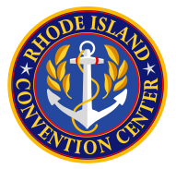

Rhode Island Convention Center Authority
459th Board Meeting
Monday, March 8, 2021
11:00 AM
Special Meeting
Meeting Notice and Agenda
Zoom Meeting

Join Zoom Meeting
https://us02web.zoom.us/j/89268399931

Meeting ID: 892 6839 9931
One tap mobile
+19294362866,,89268399931# US (New York)

Dial by your location
+1 929 436 2866 US (New York)
Meeting ID: 892 6839 9931

  - Call to Order

  - Consideration of adoption of a Resolution authorizing the issuance of the
Authority’s Refunding Revenue Bonds, 2021 Series A – Eugene Bernardo

  - Authorization to issue a Request for Proposals for Financial Statement
Audit Services – Michael Crawley

Please note that the meeting is being held by video/audio conferencing
through a Zoom Meeting via the indicated website

Posted 03/03/2021

PARTICIPANTS REQUIRING SPECIAL CONSIDERATION OR INFORMATION, PLEASE CONTACT EILEEN SMITH AT 351-4295, TTY 711 THREE DAYS PRIOR TO THE MEETING.

